Week 1 CT

John Wensink

Principles of Programming (CSC500-2)

Colorado State University – Global Campus

Steven Evans

January 17 2024

Week 1 CT

In this first Critical Thinking assignment, we were asked to create two similar Python programs. Both programs ask the user to input two numbers, I selected the data type as integer although a float would also have been appropriate if we wanted to work with decimals. Part one of the assignment goes on to ask for code to add num1 and num2 as well as subtract num2 from num1. Replit IDE was selected for this purpose as I was able to solicit multiple inputs without having to use the split() function on the input line (geeksforgeeks, 2023)

**Part 1**

For the first part of the assignment, here is a screenshot of the code executing.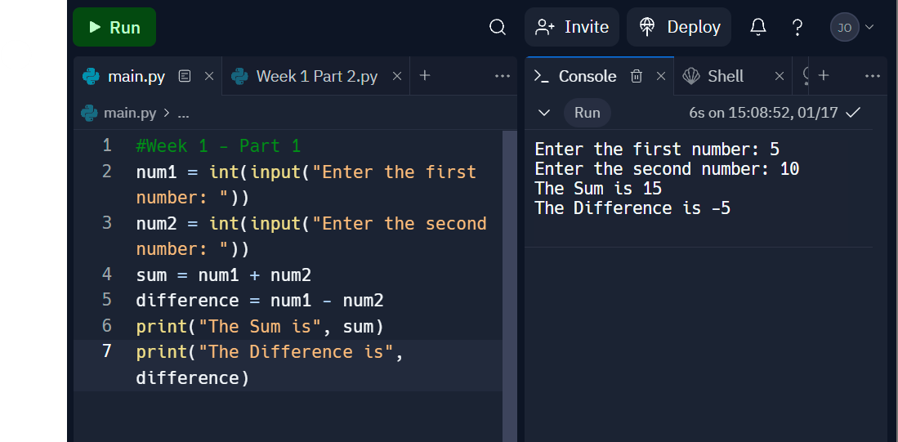

The source code for this is:

#Week 1 - Part 1

num1 = int(input("Enter the first number: "))

num2 = int(input("Enter the second number: "))

sum = num1 + num2

difference = num1 - num2

print("The Sum is", sum)

print("The Difference is", difference)

The inspiration for code was found in the ZyBooks ()

To generate the pseudocode, I used a generative AI (ChatGPT, 2024) to get a framework as I was unfamiliar with the concept. Please let me know if citing this as a source is unacceptable, and I will hand-type and resubmit. As the term pseudocode seems loosely defined, another option to create this is found in BlueNexus’ python2pseudo (2023) application from Git Hub Gist. 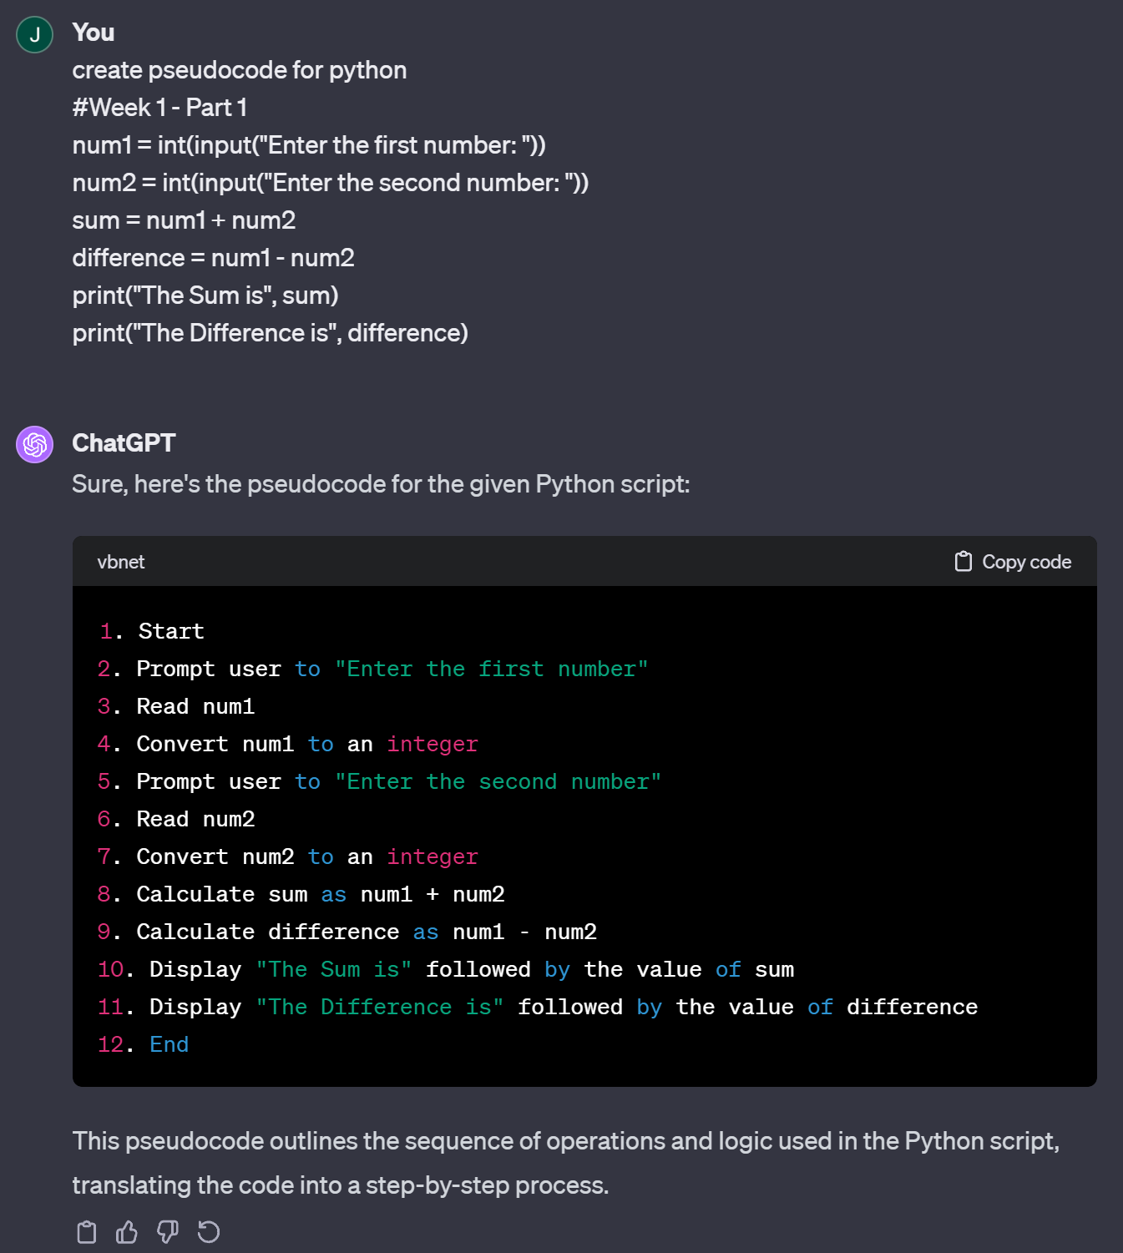

**Part 2**

For the second part of this assignment, instead of adding and subtracting num1 and num2, we will use the operations of multiplication and division. Here is a screenshot of the code executing.

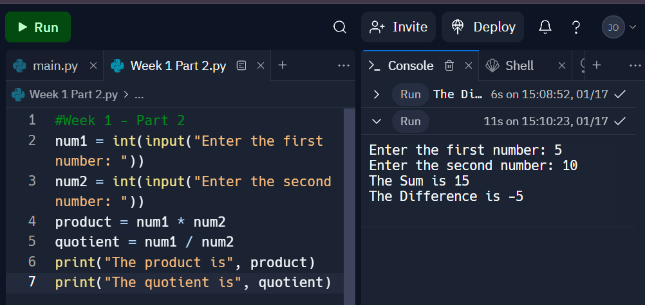

The source code for this is:

#Week 1 - Part 2

num1 = int(input("Enter the first number: "))

num2 = int(input("Enter the second number: "))

product = num1 * num2

quotient = num1 / num2

print("The product is", product)

print("The quotient is", quotient)

Here is the pseudo-code for part 2.

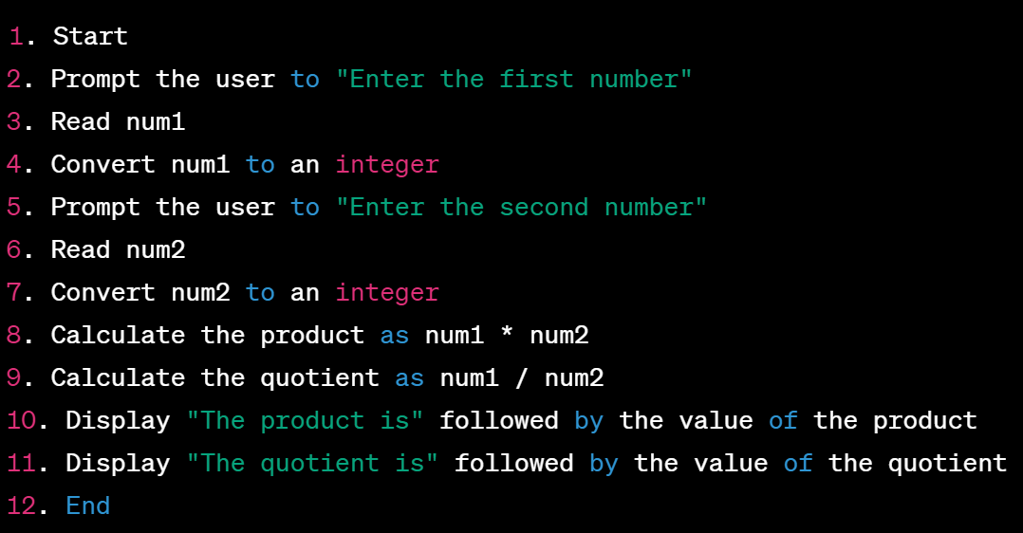

Finally, the code was uploaded and saved in my public Git repository (2024.)

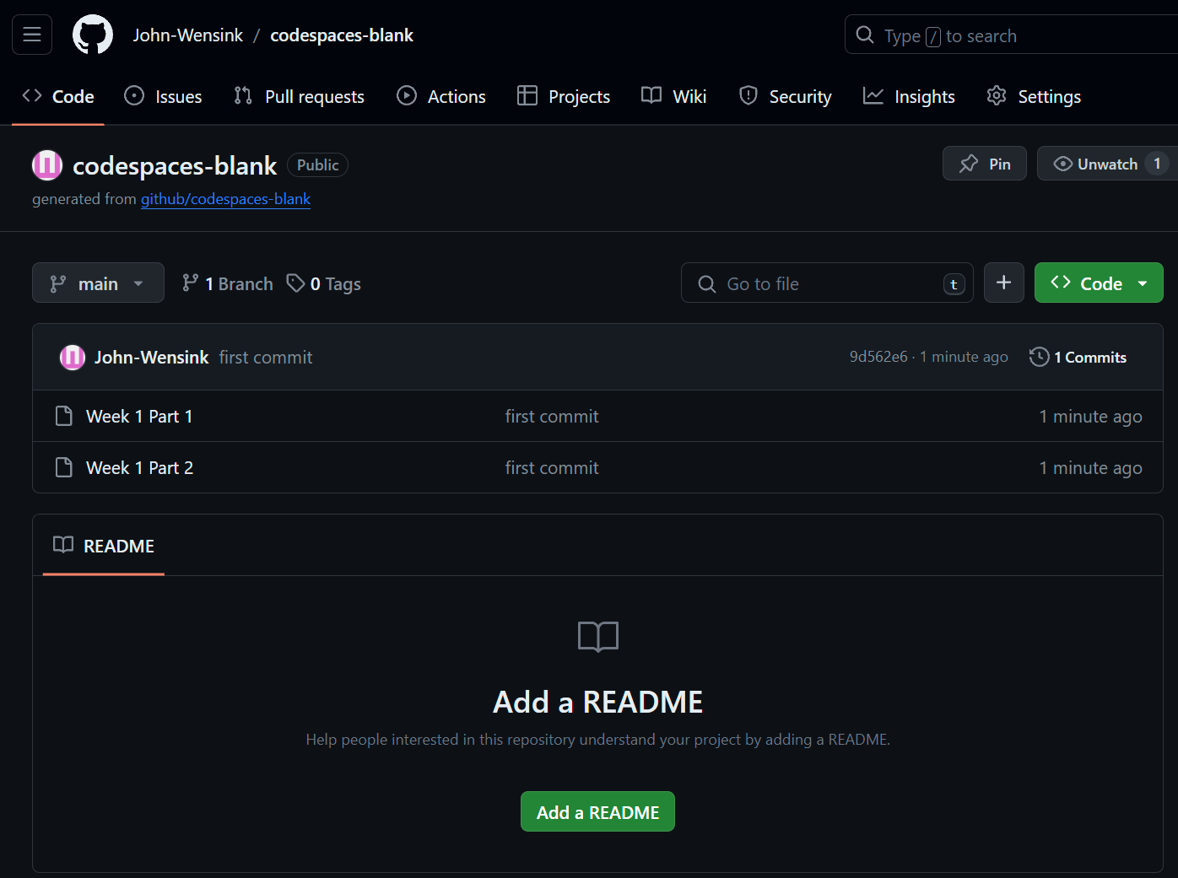

References

BlueNexus. (n.d.). *Python to pseudocode converter*. GitHub Gist. https://gist.github.com/BlueNexus/599962d03a1b52a8d5f595dabd51dc34

Geeksforgeeks. (2023, March 23). *Taking multiple inputs from user in python*. GeeksforGeeks. https://www.geeksforgeeks.org/taking-multiple-inputs-from-user-in-python/

Lysecky, R., & Vahid, F. (2019). Module 1: Introduction to Programming Concepts. In *CSC500: Principles of Programming ZyBook*. Zyante Inc.

Wensink, J. (2024, January 17). *John-Wensink Git Hub Codespaces*. GitHub. https://github.com/John-Wensink/codespaces-blank